

* **Overview:**

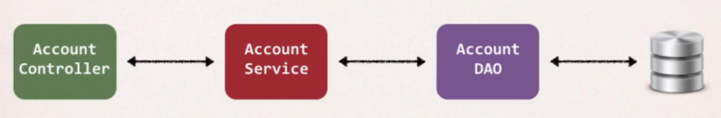Application Architecture: **Service layer design pattern**

We will use this to apply some AOP concept.

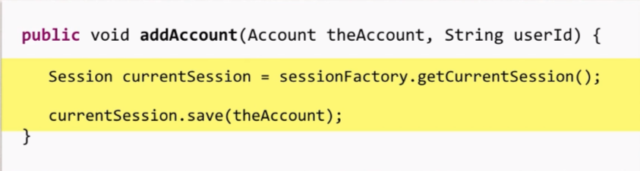Consider this code for Data Access Object (DAO)

Now There is some new Requirement comes **from the Boss**:

* Need to add logging to our DAO Methods.
* Add some logging statements before the start of the method.
* Possibly more places, but get started on that ASAP!

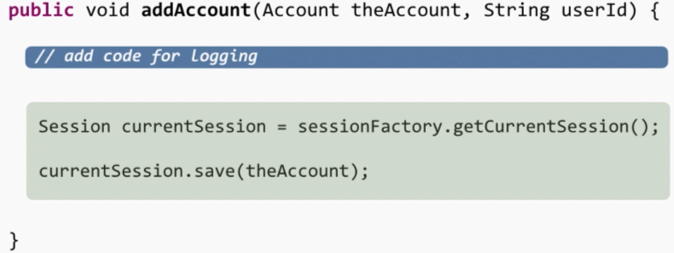 So, we have added the logging message using Sys.println or log4j, etc.

But **the BOSS** come up with **one more requirement** that we need to add some security code tour DAO and Make sure user is authorized before running the DAO method.

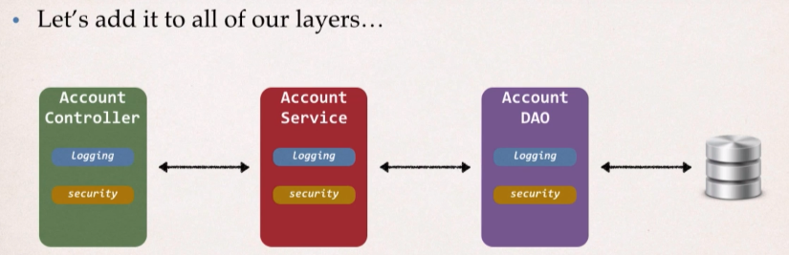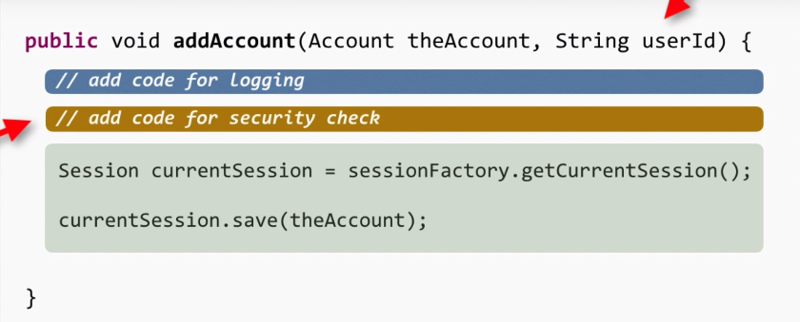But we need to add them to all the layers, i.e. in Service layer, DAO layer, controller layers.

Now what next can we except; replicate the work in whole system i.e. to all other 100 classes.

Two major problems we have here:

1. **Code tangling**

* For a given method: addAccount(…)
* We have logging and security code tangled in

1. **Code Scattering**

* If we need to change the logging or security code
* We have to update All Classes. i.e., may be in 1000 classes.

**Other possible solutions?**

1. **Inheritance?**

* Every class would need to inherit from a base class
* Can all classes extends from your base class? … plus no multiple inheritance.

1. **Delegation?**

* Classes would delegate logging, security calls
* Still would need to update classes for that support if we wanted to
* Add/remove logging or security
* Add new Features like auditing, API management, Instrumentation.

So, we didn’t solve the original problem.

**Aspect Oriented Programming comes into Rescue.**

**Aspect Oriented Programming:**

* Programming technique based on concept of an aspect.
* Aspect encapsulates cross-cutting logic.

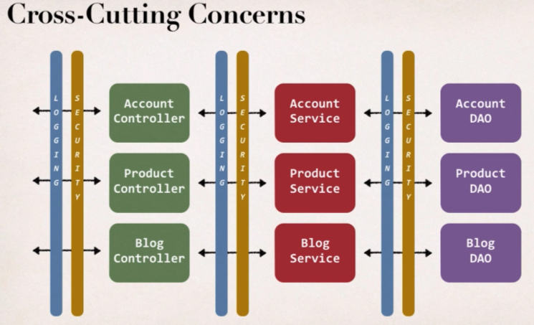**Cross-Cutting Concerns**: This is a buzz word that we are going to hear everywhere when it comes to aspect-oriented programming. **Concerns** basically means logic or functionality i.e., a basic infrastructure code that all application needs.

Therefore, we encapsulate the common logic and then apply accordingly on the different areas in our application.

**Aspects:**

* Aspects can be reused at multiple locations.
* An Aspect is just a class, and the same aspect can be applied to different areas of my application based on the configuration.

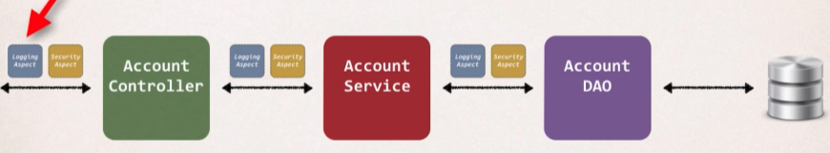Like In the configuration we can say apply the logging Aspects to the Account Controller class, or in Account Service class, or in Account DAO class.

**AOP Solution:**

Apply the Proxy design pattern.

So, we have our Main App and the target object and calling the method doSomeStuff(); now the main() app has no idea of any AOP or aspects and it will simply gonna make a method call, and its very similar to make a phone call to our friend where we pick up the phone and call simply but behing the scene we can think like it’s being monitored and similarly we can think like logging aspect and Security aspect is listening our conversation and they can take any action based on what we say or 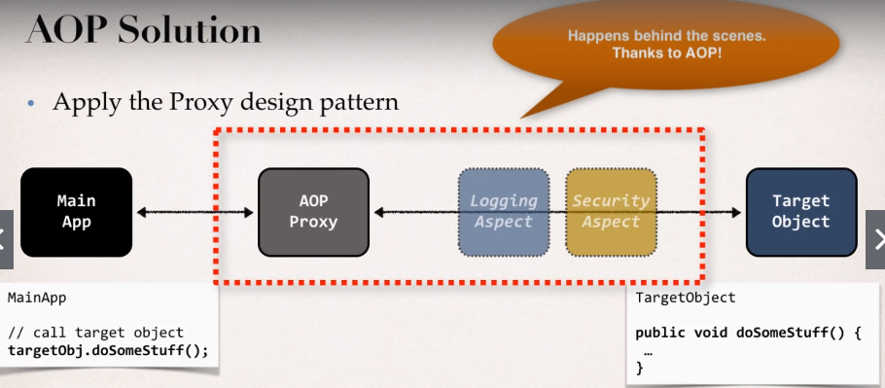pass, so it’s can be think like some Spies.

**Benefits of AOP:**

1. **Code for Aspect is defined in a single class.**

* Much better than being scattered everywhere.
* Promotes code reuse and easier to change.

1. **Business code in your application is cleaner.**

* Only applied to business functionality: addAccount
* Reduce code complexity.

1. **Configurable**

* Base on configuration, apply Aspects selectively to different parts of app
* No need to make changes to main Application code …very important!

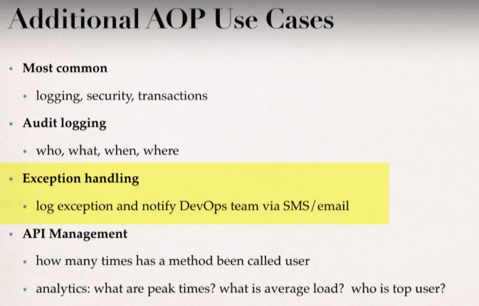

**Disadvantages:**

* To many aspects and app flow is hard to follow.

Consider the case where there is project of 20 developer and each creating their own set of 20 to 30 aspects then applying to the system, then it’s really being hard to follow what’s being called.

* Minor performance cost for aspect execution (run-time Weaving).

So, we don’t want to overdo it, as If we have small number of aspects, we may not even notice the performance cost it can be very expensive on execution of operations in case there is lots of aspects.

* **Comparing AOP And AspectJ**

AOP terminology:

**Aspect:** Module of code for a cross-cutting concern (logging, security,)

**Advice:** What action is taken and when it should be applied.

**Join Point:** when to apply code during program execution.

**Pointcut:** A predicate expression for where advice should be applied.

**Advice type**

* **Before Advice**: run the code before the actual method executes.
* **After Finally advice**: run the code after the method finishes (like finally block of a try catch).
* **After returning advice**: run the code after the method for a successful execution.
* **After Throwing advice**: run the code after method (if exception thrown)
* **Around Advice**: run the code before and after the method.
* **Weaving:** Connecting aspects to target objects to create an advised object.

* **There are different types of weaving:** Compile-time, load-time or run-time weaving.
* **Regarding Performances:**  Run time weaving is the slowest.

**AOP frameworks**

There are two leading AOP Frameworks for Java

1. Spring AOP
2. AspectJ

**Spring AOP**

* Spring provides AOP Support and it uses AOP in the background.
* Key Components of Spring where it uses AOP: Security, transactions, caching etc.
* Spring makes use of runtime weaving of aspects, so,spring makes use of proxy pattern to advice an object so the main application will talk to the proxy and then the aspects are processed and then it makes to the actual objects.

**AspectJ**

* Original AOP framework, released in 2001.
* <https://www.eclipse.org/aspectj>
* It provides complete support for AOP.
* Rich support for
* **Join Points**: method-level, constructor, field
* 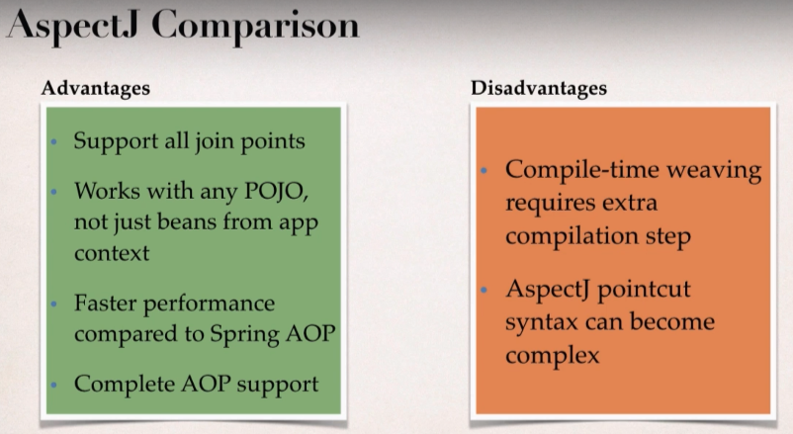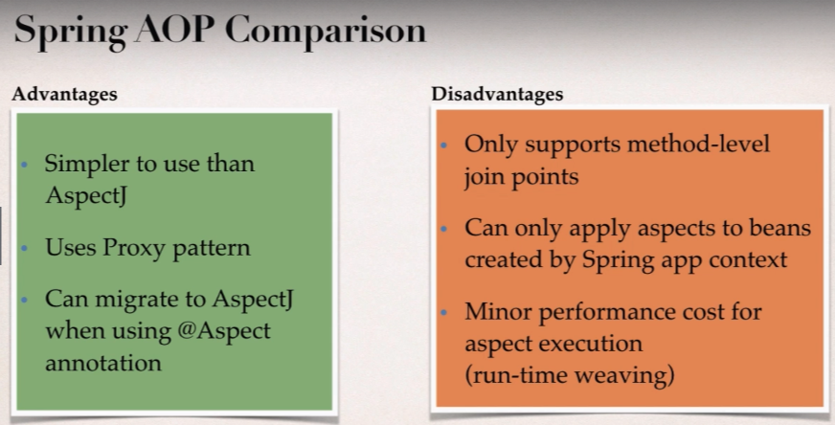**Code weaving**: compile-time, post compile-time and load-time
* In short, AspectJ is very fast but it involves lots of complexity with it.
* And Spring AOP is a light implementation of AOP but it solves common problems in enterprise application.

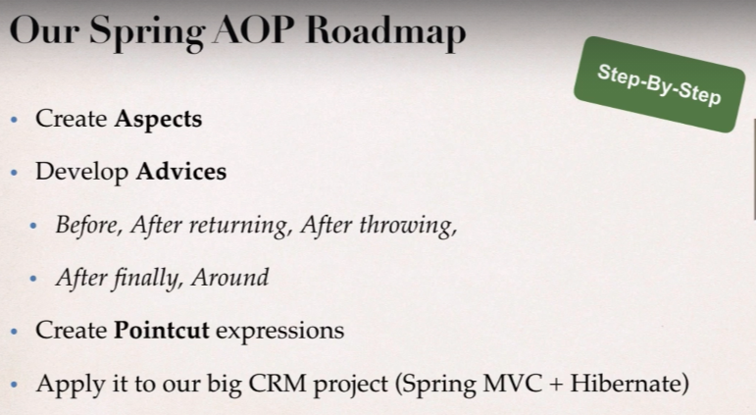

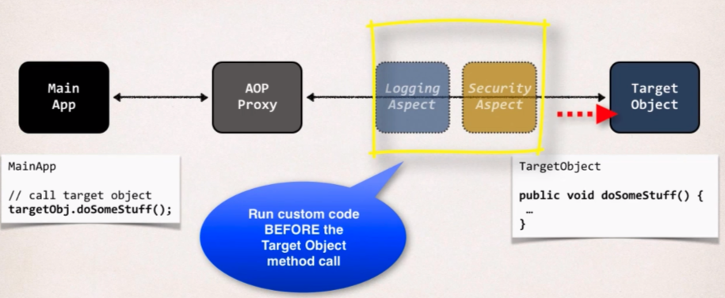Example that we are going to discuss; Here we want our custom code to execute before the target method execution.

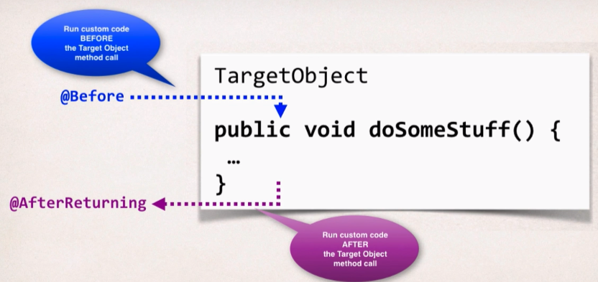**Advice-Interaction:**

**@BeforeAdvice – Use cases:**

**Most Common:**

* Logging, security, transaction.

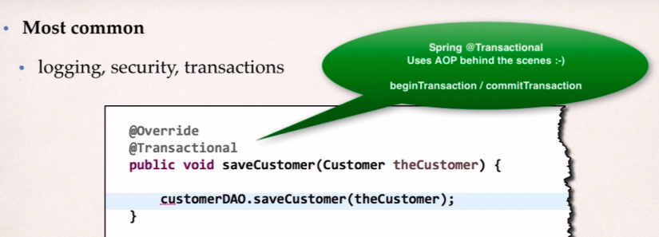And @transactional actually uses AOP behind the scene for begin transaction and session creation, session closing and committing the transaction.

* **Audit logging**

So, when the method gets called then we can log who, what, when, where; may be we want to keep that information so we can use Audit logging for that.

* **API Management**

How many times has a method been called and from there we can use some data analytics like what are the peak times? What is the average load, who is top user?

In the coding example that we are going to discuss here:

**Prerequisite:** Adding AspectJ JAR file

* Need to download AspectJ Jar file.
* Even though we are using Spring AOP still we need AspectJ JAR file.
* Why?
* Spring AOP uses some of the AspectJ annotations.
* Spring AOP uses some of the AspectJ classes.

**Spring AOP is lightweight AOP implementation.**

**Development Process:**

1. 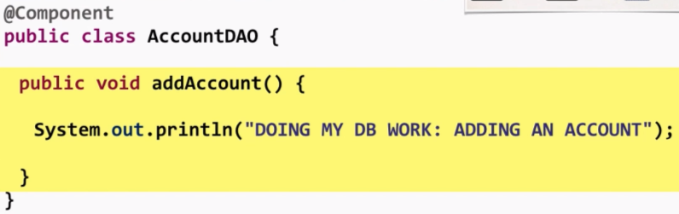Create target object: AccountDAO.
2. 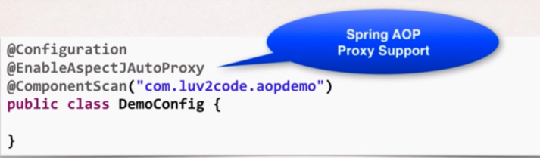Create Spring Java Config class.

This @EnableAspectJAutoProxy will allow us to make proxy in the background using Spring AOP with support from AspectJ.

1. 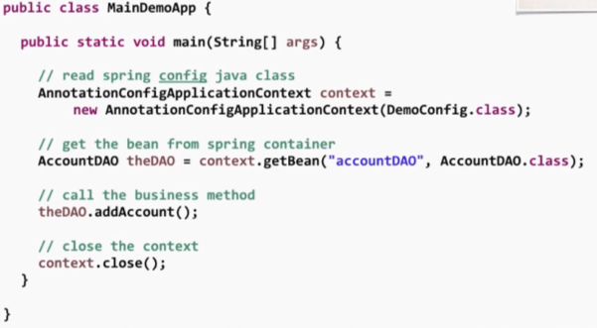Create main app.
2. Create Aspect with @Before advice.

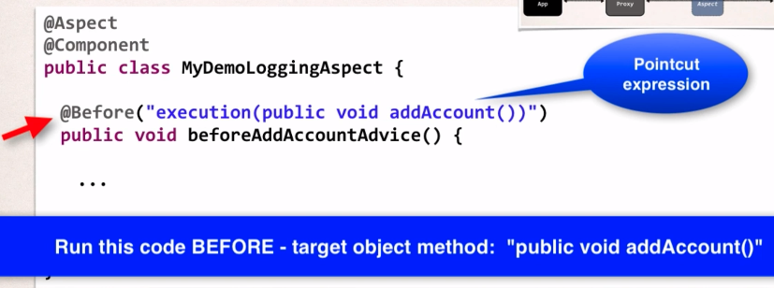We will create a normal class with @Component annotation and further we will add up @Aspect to mention that it’s a special aspect class and in the result this class can run as our spy network and they can listen in on communication behind the scene.

We can give any method name we want and then inside it we can provide any custom code for logging or security. And the given code will execute before the given target object method present in pointcut expression.

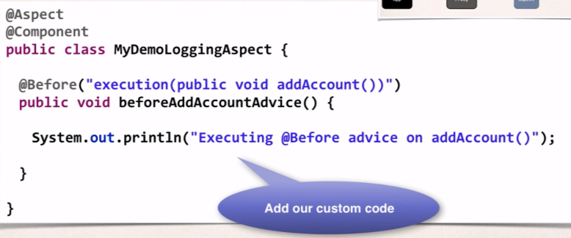

Best Practice: Aspect and Advices

* Keep the code small
* Keep the code fast
* Do not perform any expensive/slow operations
* Get in and out as QUICKLY as possible.
* To download the AspectJ Jar file visit: <https://mvnrepository.com/artifact/org.aspectj/aspectjweaver>
* 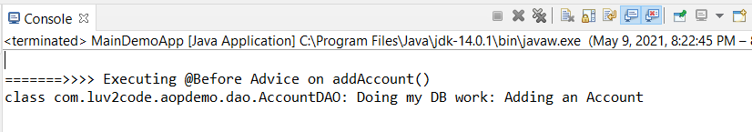**Output** associated with our main() app:
* What is Pointcut Expression? 🡺 “@Before("execution(public void addAccount())")”

So, basically it will tell Spring AOP system if the given conditions met then apply the below advice code.

Spring AOP actually uses the AspectJ’s pointcut expression Language. AspectJ has lots of pointcut, but we will simply start with execution pointcut.

**Pointcut Expression Language**

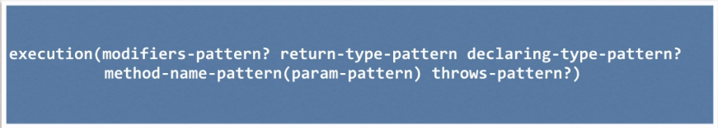We will use this to define the predicate to actually match on a given method.

* ? represents optional pattern, which means we don’t need to give those patterns if we don’t need them. And Pattern can also make use of Wildcards: **\*(matches on everything)**
* Modifiers-pattern: where Spring AOP only supports **Public**
* Return-type-pattern: which means is it returning void, Boolean, String, List<Customer>, etc.
* Declaring-type-pattern: what is the class name of the type that we are going to use for this given method.
* Method-name-pattern: we can give the actual name of the method or wildcards.
* Param-pattern: we can match a method for a given parameter list.
* Throws-pattern: it matches to a method that throw the given exception.

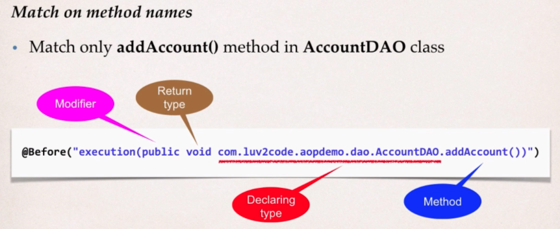**Example 1:**

In the above example, any calls to the addAccount() method in the AccountDAO class will execute our given advice that we have setup for AOP, and this is all for matching on execution calls on given method.

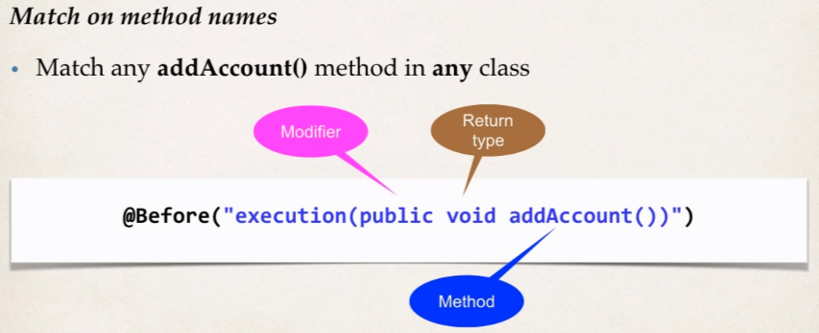**Example 2:**

Any call to addAccount() method in any class, and this is where our spy network will jump and it will get to know that main() method is calling addAccount() then it will decide to apply the advice by running our AOP code then the actual method will get executed.

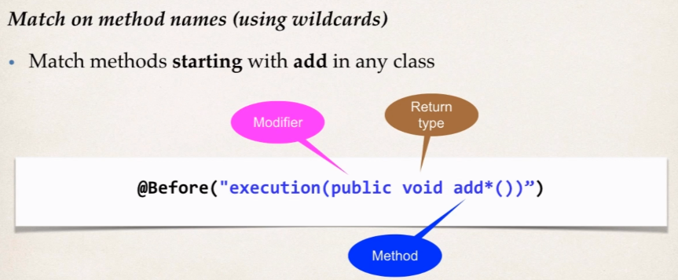**Example 3:**

Here we are trying to match to any method starting from **add** and belongs to any class. Here Spring AOP will see the wildcard (*) and it will check for any method starting from **add** then we will apply our advice.

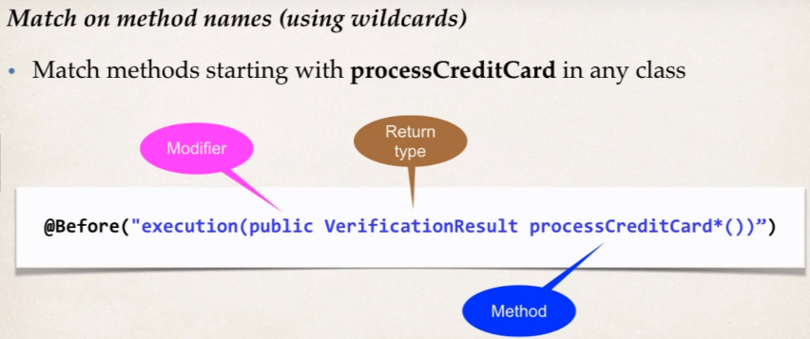**Example 4:**

So, any method whose return type is VerificationResult and having access modifier public and method name starts with processCreditCard then Spring AOP will apply our advice.

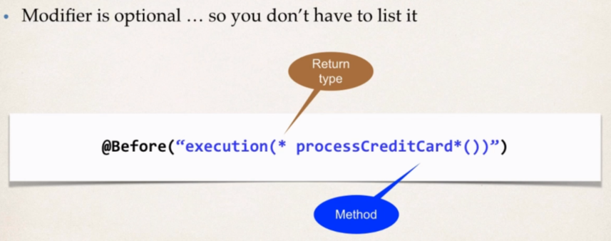**Example 5:**

As we know, modifier is optional and it’s not mandatory to mention it but return type is mandatory and here we are accepting method to have any type of modifier and is method name starts with processCreditCard the Spring AOP will apply our advice on that method.

**Use Case:** Now let add another class having the same method: addAccount() and will keep the pointcut expression same we had.

**File:** MembershipDAO.java

@Component

**public** **class** MembershipDAO {

**public** **void** addAccount() {

System.***out***.println(getClass()+" Doing Stuff: Adding a membership account");

}

}

**File:** MyDemoLoggingAspect.java

Keeping the aspect class as it is.

@Aspect

@Component

**public** **class** MyDemoLoggingAspect {

//this is where we will add all of our related advices for logging

//let's start with @Before advice

//@Before("execution(public void addAccount())")

@Before("execution(public void addAccount())")

**public** **void** beforeAddAccountAdvice() {

System.***out***.println("\n=======>>>> Executing @Before Advice on addAccount()");

}

}

**File:** MainDemoApp.java

**public** **class** MainDemoApp {

**public** **static** **void** main(String[] args) {

//read spring config java class

AnnotationConfigApplicationContext context =

**new** AnnotationConfigApplicationContext(DemoConfig.**class**);

//get the bean from spring container

AccountDAO theAccountDAO = context.getBean("accountDAO",AccountDAO.**class**);

MembershipDAO theMembershipDAO = context.getBean("membershipDAO", MembershipDAO.**class**);

//call the business method

theAccountDAO.addAccount();

theMembershipDAO.addAccount();

//close the context

context.close();

}

}

So we are calling the addAccount() method and in result the aspect class will apply our advice, and later the addAccount() method will execute.

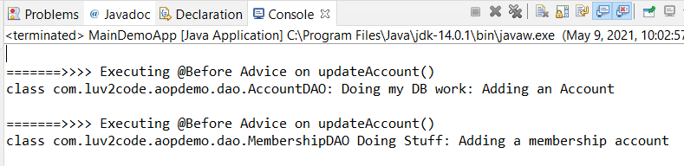**Output:**

**Use Case:** Now this time we just want to call the addAccount() method of Account class but not the Membership class, so we need to update the pointcut expression accordingly.

Actually, we need to be super specific in this example.

We need to enter the qualified class name then only, the addAccount() method belong to that class will get applied by the advice mentioned in the aspect class.

* 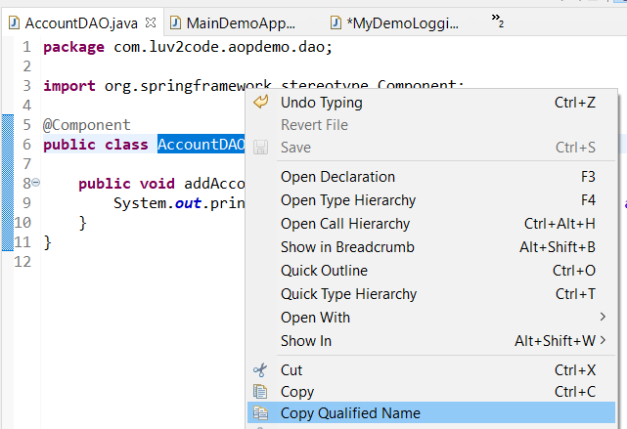To copy the Qualified class name: eclipse shortcut:

**File:** MyDemoLoggingAspect.java

Keeping the aspect class as it is.

@Aspect

@Component

**public** **class** MyDemoLoggingAspect {

//this is where we will add all of our related advices for logging

//let's start with @Before advice

//@Before("execution(public void addAccount())")

@Before("execution(public void com.luv2code.aopdemo.dao.AccountDAO.addAccount())")

**public** **void** beforeAddAccountAdvice() {

System.***out***.println("\n=======>>>> Executing @Before Advice on addAccount()");

}

}

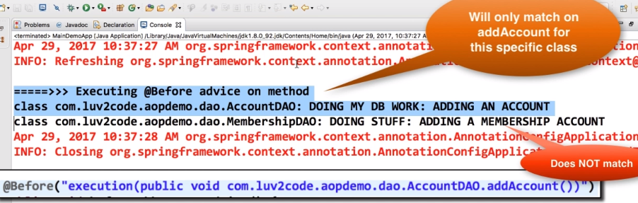**Output:**



**Match Method starting with “add” in any class:**

**File:** MyDemoLoggingAspect.java

@Aspect

@Component

**public** **class** MyDemoLoggingAspect {

//this is where we will add all of our related advices for logging

//let's start with @Before advice

//@Before("execution(public void addAccount())")

@Before("execution(public void add*())")

**public** **void** beforeAddAccountAdvice() {

System.***out***.println("\n=======>>>> Executing @Before Advice on addAccount()");

}

}

**File:** MainDemoApp.java

**public** **class** MainDemoApp {

**public** **static** **void** main(String[] args) {

//read spring config java class

AnnotationConfigApplicationContext context =

**new** AnnotationConfigApplicationContext(DemoConfig.**class**);

//get the bean from spring container

AccountDAO theAccountDAO = context.getBean("accountDAO",AccountDAO.**class**);

MembershipDAO theMembershipDAO = context.getBean("membershipDAO", MembershipDAO.**class**);

//call the business method

theAccountDAO.addAccount();

System.***out***.println("\n\n");

theMembershipDAO.addSillyMember();

//close the context

context.close();

}

}

**File:** MembershipDAO.java

@Component

**public** **class** MembershipDAO {

**public** **void** addSillyMember() {

System.***out***.println(getClass()+" Doing Stuff: Adding a membership account");

}

}

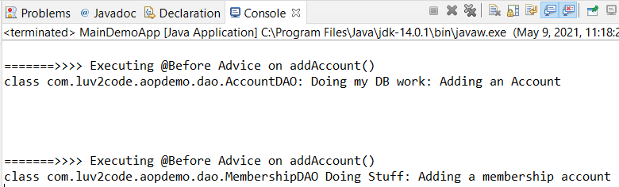**Output:**

**Method Based On Return Type:**

Here, advice will get applied to all the methods start with “add” and whose return type is void. If return type not matches then advice will not be applied.

We will change the return type of addSillyMember() member in MembershipDAO class.

**File:** MembershipDAO.java

@Component

**public** **class** MembershipDAO {

**public** **boolean** addSillyMember() {

System.***out***.println(getClass()+" Doing Stuff: Adding a membership account");

**return** **true**;

}

}

**File:** MyDemoLoggingAspect.java

@Aspect

@Component

**public** **class** MyDemoLoggingAspect {

//this is where we will add all of our related advices for logging

//let's start with @Before advice

//@Before("execution(public void addAccount())")

@Before("execution(void add*())")

**public** **void** beforeAddAccountAdvice() {

System.***out***.println("\n=======>>>> Executing @Before Advice on addAccount()");

}

}

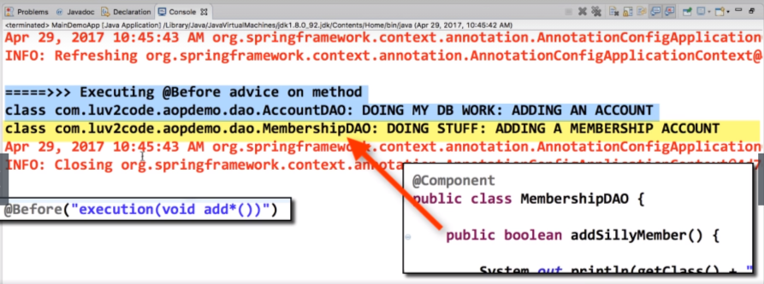**Output:**

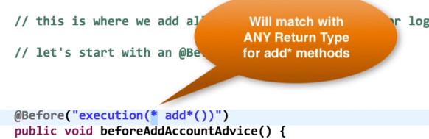

This time we don’t care what the return is, we just put wildcard there and we are allowing any return type, be it string, Boolean, customer class, etc.

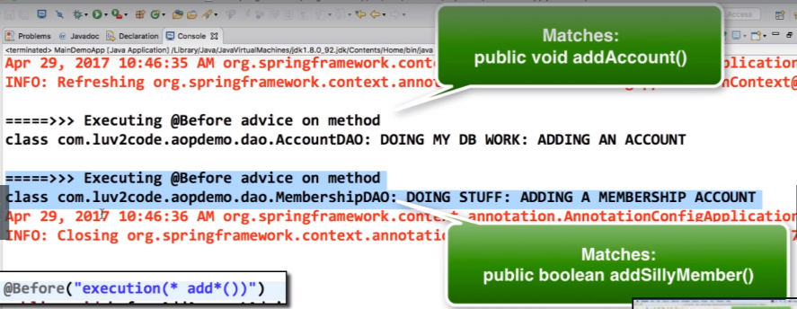**Output:**

**Match on Parameters of Methods:**

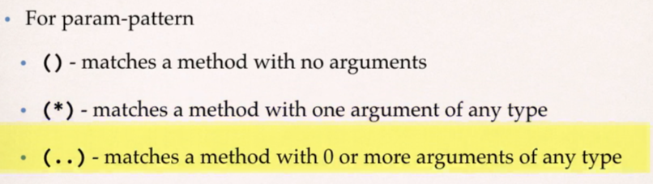

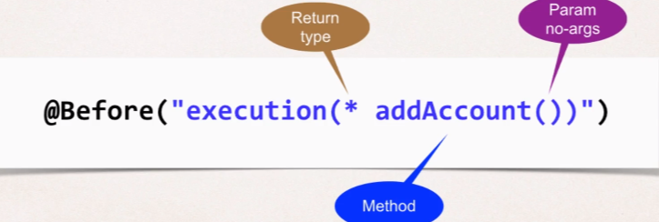

**Examples:**

1. Match **addAccount** methods with no arguments.
2. Match **addAccount** methods that have **Account** object as param. So, in this case we need to give fully qualified name of Account class.

**Explanation:**

File: MyDemoLoggingAspect.java

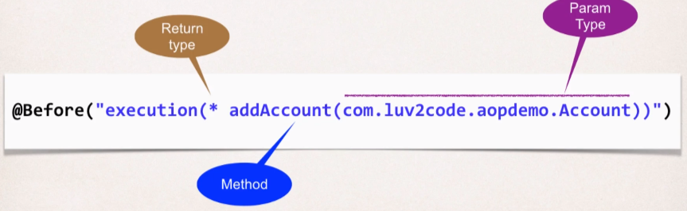

Create a class Account, and put it as a param in addAccount method in the AccountDAO class.

**public** **class** Account {

**private** String name;

**private** String level;

**public** String getName() {

**return** name;

}

**public** **void** setName(String name) {

**this**.name = name;

}

**public** String getLevel() {

**return** level;

}

**public** **void** setLevel(String level) {

**this**.level = level;

}

}

File: AccountDAO.java

@Component

**public** **class** AccountDAO {

**public** **void** addAccount(Account theAccount) {

System.***out***.println(getClass()+": Doing my DB work: Adding an Account");

}

}

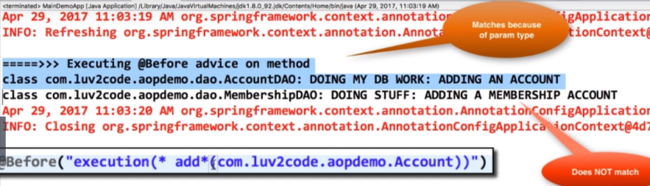 **Output:**

**Note:**

1. in case we don’t give the fully qualified Class name then it will throw error.
2. And if there is one more param after Account object then we can mention wildcards after that which means there can 0 or more params followed by Account object.

Ex. Putting wildcards.

@Before("execution(* add*( com.luv2code.aopdemo.Account, ..))")

**public** **void** beforeAddAccountAdvice() {

System.***out***.println("\n=======>>>> Executing @Before Advice on addAccount()");

}

1. Match **addAccount** methods with **any number of arguments**.

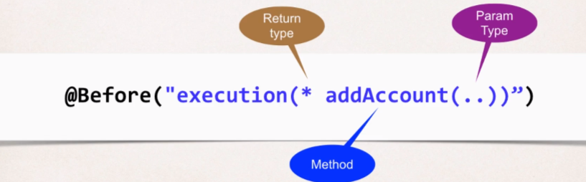

1. Match any method in our **DAO package**: **com.luv2code.apodemo.dao**

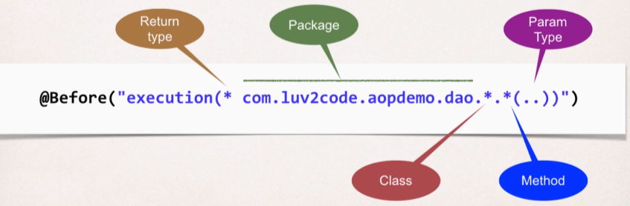

**Explanation:**  Copy the package name such as: **com.luv2code.aopdemo.dao**, then spring AOP will only apply the advice on the objects created against the classes inside the mentioned package name.

* **Pointcut Declarations:**

**Problem**:

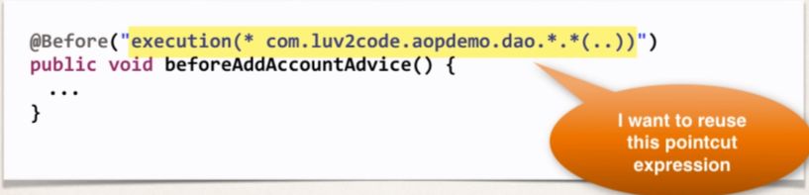How can we reuse a pointcut expression? As we want to apply it to multiple advices in my AOP aspect.

Possible solutions are:

1. Copy and paste, but it’s now ideal as on update we need to go to all the locations.
2. So, ideal solution should be creating a pointcut declaration once and apply it to multiple advices.

Development Process:

1. Create a pointcut declaration

* We will use **@Pointcut** annotation.
* And then we will have a **reference** for the pointcut expression.
* Then setup a method name that we will use to reference the pointcut.
* 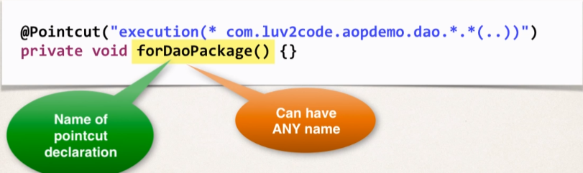Then we can take the method name which is having the reference of the pointcut expression and apply it to any number of advices.

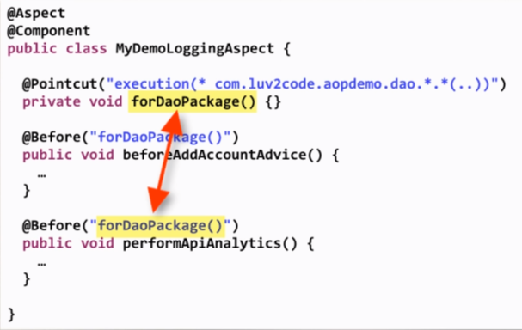

**Benefits of Pointcut Declarations:**

* Easily reuse pointcut expressions
* Update pointcut at one location.
* Can also share and combine pointcut expressions.

1. pointcut declaration to advices.

* **Combining Pointcuts:**

Problems

1. How to apply multiple pointcut expressions to a single advice.
2. Execute an advice only if certain conditions are met.
3. For ex: All methods in a package **EXCEPT** getter/setter methods.

We can combine pointcut expressions using **logic operators**:

* **AND (&&)**
* **OR (||)**
* **NOT (!)**

**Pointcut** expressions when we combine works like **“if”** statement.

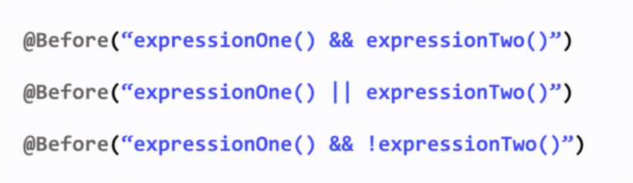The Execution happens only if it evaluates to true. Examples given below:

Example: All methods in a package **EXCEPT** getter/setter methods.

**Development Process:**

1. 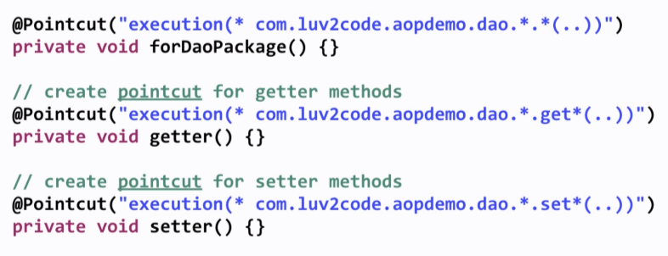Create a pointcut declarations

Now we will combine all these pointcut expressions that we have declared.

1. 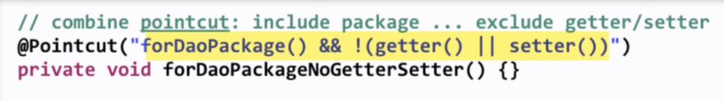Combine pointcut declarations

It means include the package but exclude any getter and setter. And we can now apply this combine pointcut on our advices.

1. Apply pointcut declaration to advices.

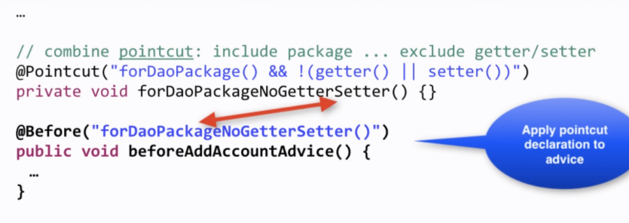

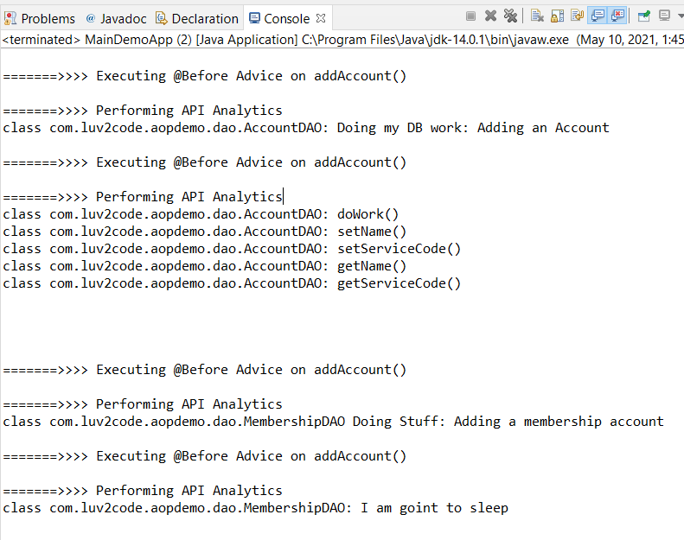**Output:** We can see in the logs that no advice is being applied to our getter/setter methods in the mentioned package inside the pointcut expression.



**Control Aspect Order** [Java project link](https://github.com/000GEV744/Spring-Git/tree/main/Spring-demo-aop-poincut-order-aspects)

How to Control the order of advices being applied?

Let say we have aspect class; named MyLoggingDemoAspect which has four advices

1. 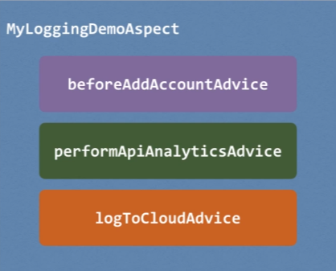beforeAddAccountAdvice
2. performApiAnalyticsAdvice
3. logToCloudAdvice

Acc. To the Specification the order of their execution is undefined, and spring will just pick one of them and run it and then pick the next and then next.

But in our app, we want to control the order on these advices inside the aspect that are applied and executed then we have to do some additional work.

**To control Order**

1. Refractor your code: Place advices in separate Aspects and
2. using this approach, we can actually control the order of the aspects using the @Order annotation.
3. It will guarantee order of when Aspects are applied.

**Development Process:**

1. **Refactor:** Place advices in separate Aspects

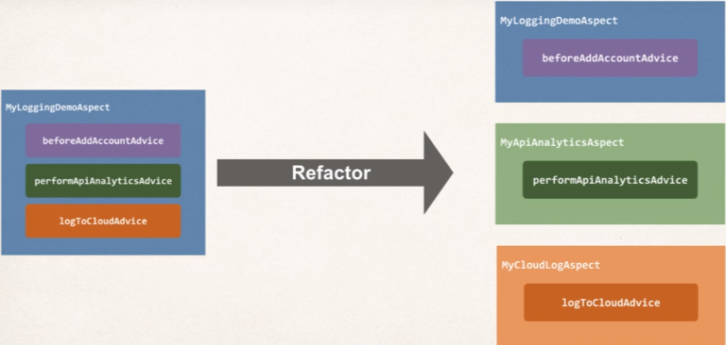So, we have divided the aspect into three other aspects:

1. MyLoggingdemoAspect
2. MyApiAnalyticsAspect
3. MyCloudLogAspect

This way we can order the different aspects.

1. 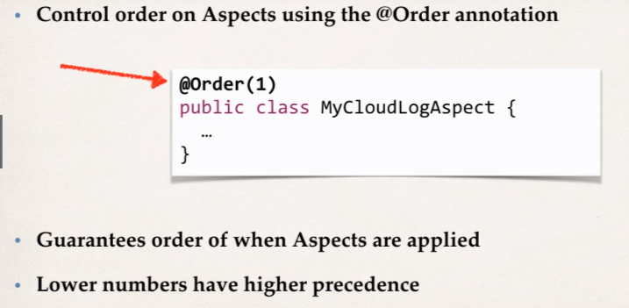Add **@Order** Annotation to Aspects

The aspects with lower number having advices will run before the aspects having higher number in the **@Order** annotation.

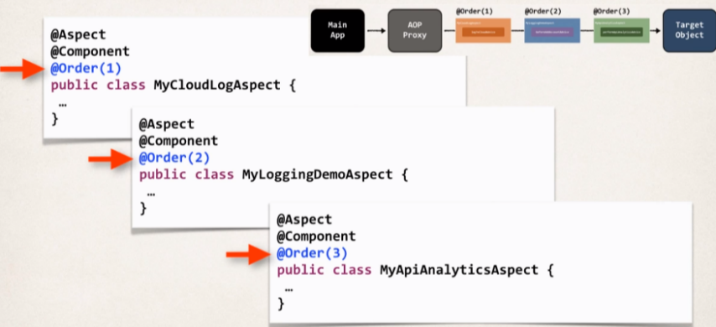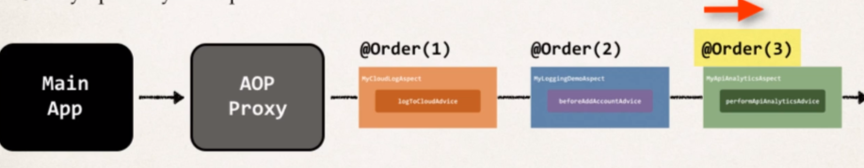So, the order in which advices of different aspect will execute:

**@Order Annotation**

* Lower numbers having higher predence
* Range: Integer.MIN_VALUE to Integer.MAX_Value.
* Negative Numbers are allowed.
* 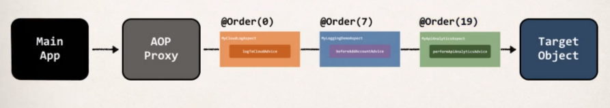Also, the order sequence does not need to be consecutive as shown in attached pic.

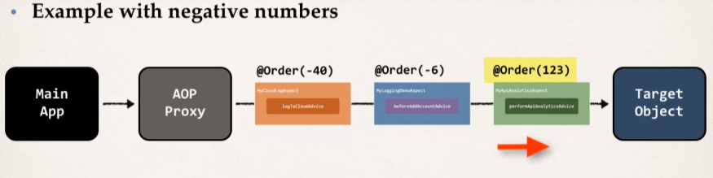

**FAQs: What if aspects have the exact same @Order annotation?**

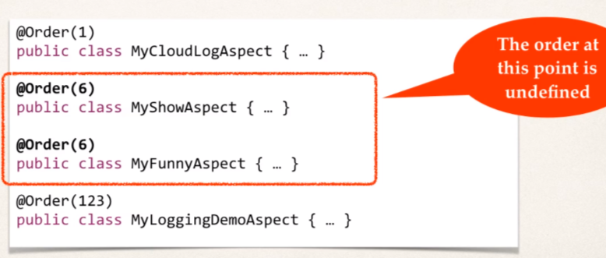Both having @Order(6) annotation then the order becomes undefined.

However, they will still run After MyCloudLogAspect and Before MyLoggingDemoApsect.



**Reading Method Arguments with JoinPoints** [Java Project Link](https://github.com/000GEV744/Spring-Git/tree/main/Spring-demo-aop-read-joinpoint)

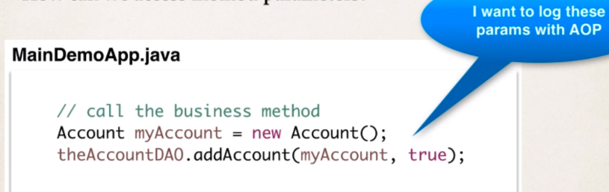**Problem**: When we are in an aspect (i.e., for logging) **then how can we access method parameters?**

**Development process:**

1. Access and display method signature.

For that we can add a new argument i.e JoinPoint which gives us information about the method which will actually execute after this advice.

And to access method signature we will be using the method getSignature() and downcast it to MethodSignature object and then we are simply printing the method signature

* 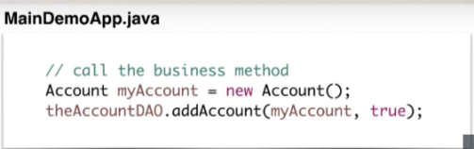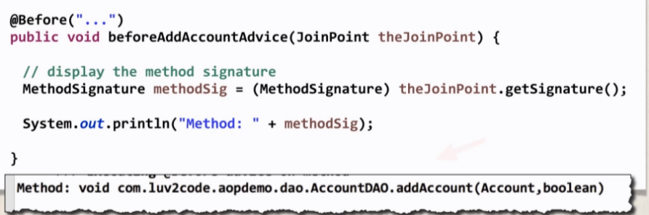**JoinPoint** Belongs to org.aspectj.lang package.

And in the **output,** we are getting fully qualified name of the method with their parameters that has to be passed.

1. Access and display method arguments.

And using the same **JoinPoint** we can get the arguments used by calling the method getArgs(), which will return an array of objects.

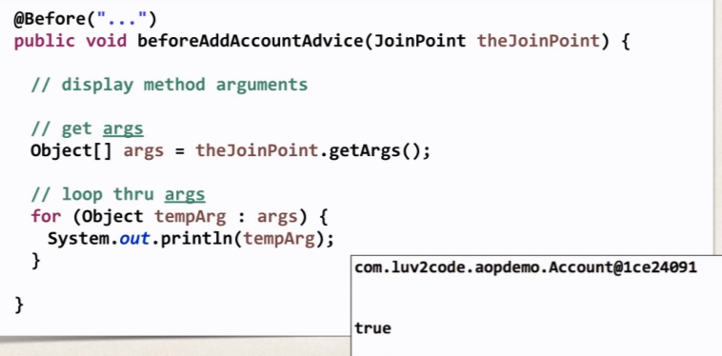

In the **output**,

We will get the account object with fully qualified class name and the Boolean value passed into the method call.

And then we can log the method signature as well as the arguments.



* **@AfterReturning Advice** [Java Project Link](https://github.com/000GEV744/Spring-Git/tree/main/Spring-demo-aop-z-after-returning)

This runs after the method’s successful execution.

With AOP, we have methods calls going in and we can preprocess using @Before, and after the target object method gets executed then on returning back then we can make use of this advice type @AfterReturning which will have code that will execute after the target object method being executed successfully.

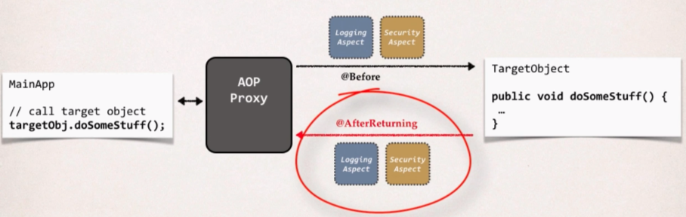

**Use Case:**

* **Most common**: Logging, security, transactions
* **Audit Logging**: Who, what, when, where
* **Post processing Data**:

1. Post process the data before returning to the caller.
2. Format the data or enrich the data.

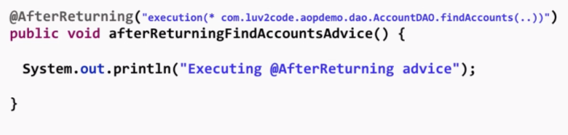Example:

**Access the Return value:**

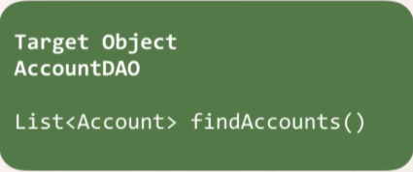Need to access the return value of called method.

As in my example here, the method after its execution is returning List of Accounts. And we want access the return value i.e., List of accounts. And want to log them or process them.

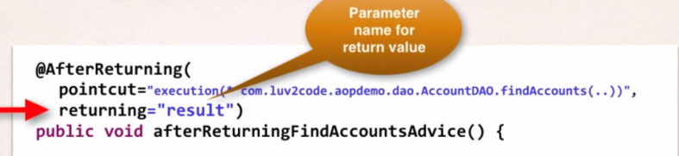So, for that we will use one attribute inside the pointcut expression returning and it keeps the parameter name which will hold the value of returned data.

We can use any name in the returning attribute inside the pointcut expression but we need to be consistent while giving the parameter to the advice.

So, we have to be consistent between the parameter args and annotation.

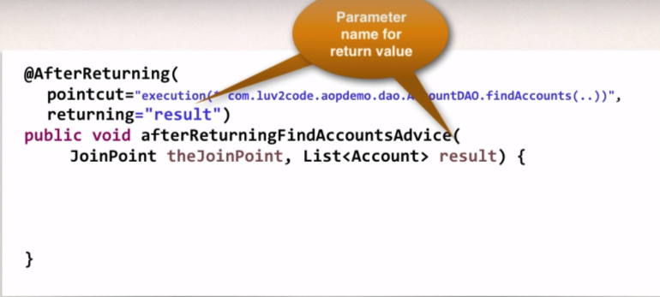**Ex:**

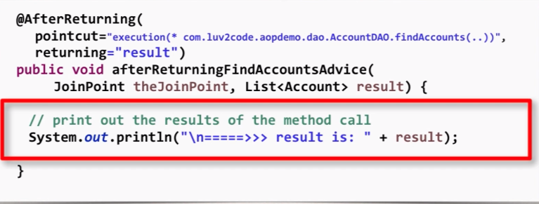And by this time, AOP has injected the return value in the variable result and we are simply printing them on the console.

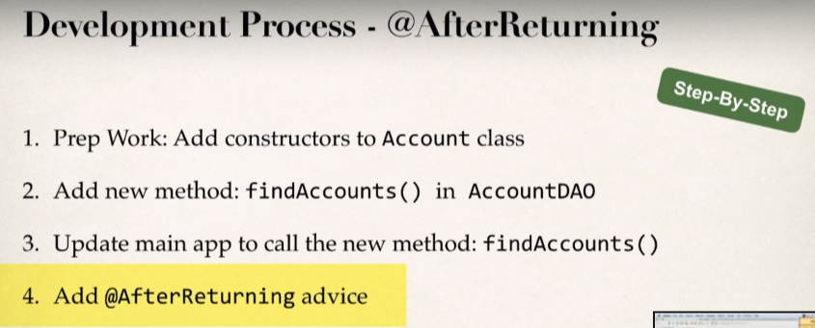**Development Process:** [AfterReturningDemoApp.java](https://github.com/000GEV744/Spring-Git/blob/main/Spring-demo-aop-z-after-returning/src/com/luv2code/aopdemo/AfterReturningDemoApp.java) is our main App

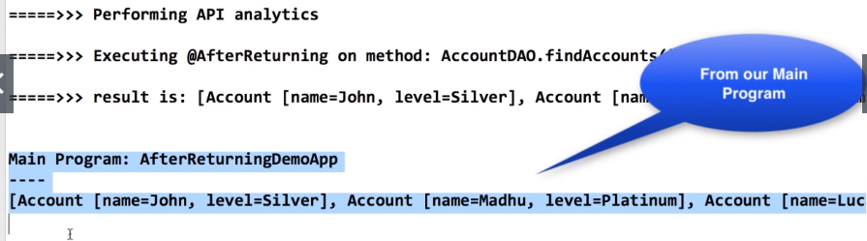**Output:** We are getting the return value inside the advice in our aspect.

**Post-processing/Modifying the Data:** [AfterReturningDemoApp.java](https://github.com/000GEV744/Spring-Git/blob/main/Spring-demo-aop-z-after-returning/src/com/luv2code/aopdemo/AfterReturningDemoApp.java)

So, we can post process the data before returning to the caller.

In this example we are fetching the first Account Object and updating the name property of the object and then it will be sent to the caller in the main App. And the calling program will get the new data in the whole process.

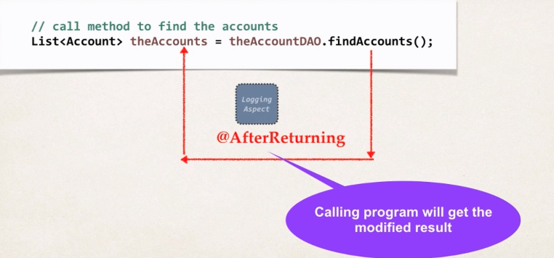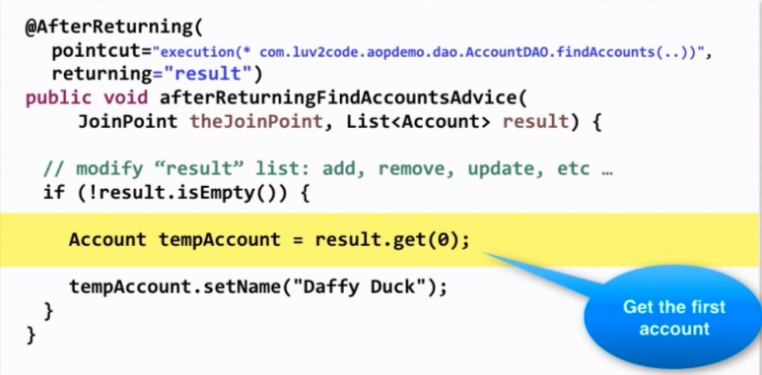So, the AOP is intercepting the calls and modifying the value in here.

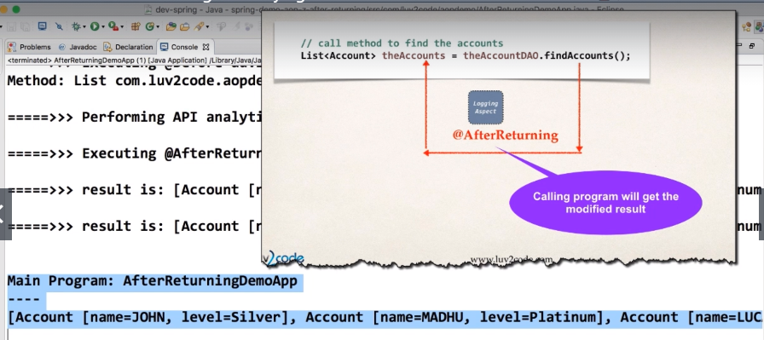Here is the Output: Converting all the names of the Account object to the uppercase.

**@AfterThrowing**

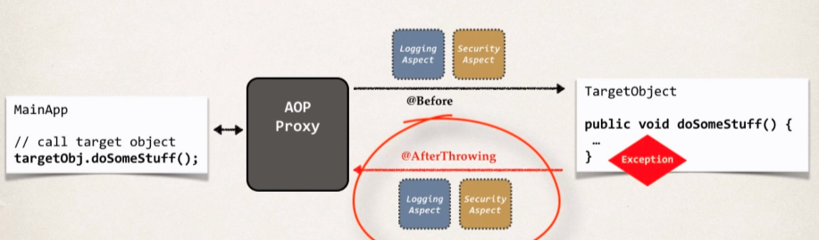Incase an exception is thrown, the using this advice type we can post process that exception which occurred in the target object.

As soon as the exception is thrown then this @AfterThrowing advice type will get triggered.

**Use Cases:**

* Log the exception.
* Perform auditing on the exception
* Notify DevOps team via email or SMS.
* 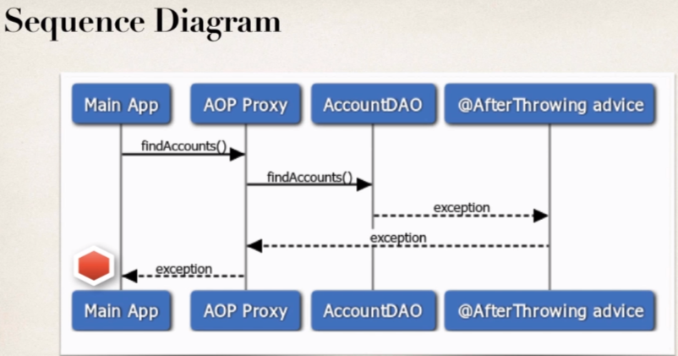Encapsulate this functionality in AOP for easy reuse.

**Example:**

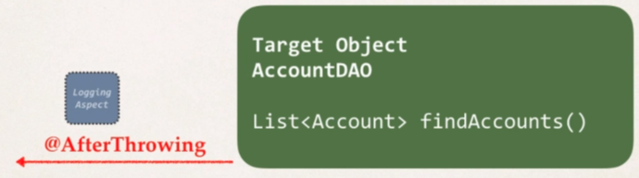We will create an advice that will run after an exception is thrown.

So, we will use this annotation called **@AfterThrowing,** then I will give the pointcut expression.

Access the Exception Object

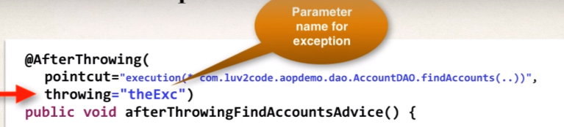For that we will use throwing attribute inside the annotation, and later we will enter on more parameter inside the method arguments which will hold the exception object.

* 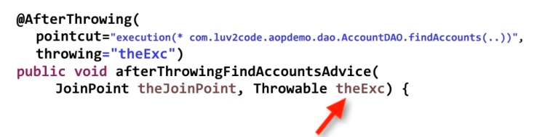Throwable theExc will matched the actual parameter that we have entered in the annotation.
* When the exception will be thrown then we can handle it in our advice and make use of this theExc object.

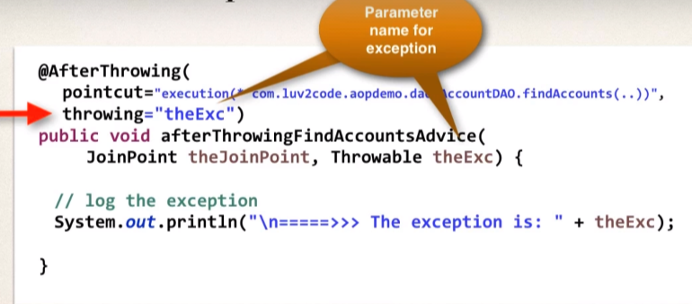

* At this point, we are only intercepting the exception (reading it).
* However, the exception is still propagated to calling program.
* Now if we want to stop the **Exception Propagation**

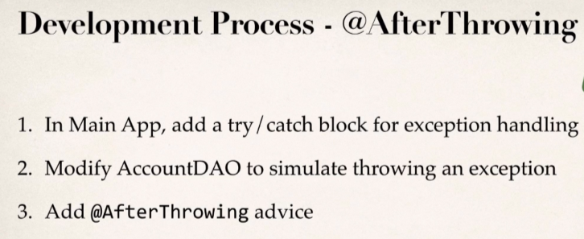Such that the exception never makes to the main app i.e calling method then we have to use @**Around** advice.

**Output:**

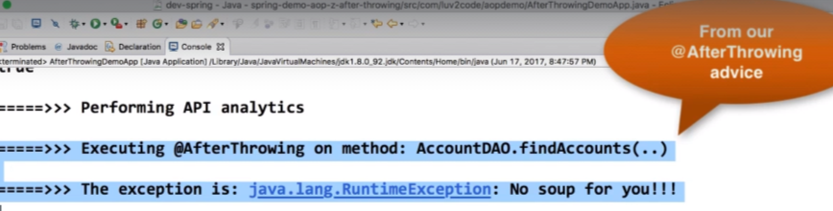And the Advice code gets triggered and log the exception before the exception make its way to the calling method, after the target method gives exception.



**@After Overview** [Java Project Link](https://github.com/000GEV744/Spring-Git/tree/main/Spring-demo-aop-zz-after-finally)

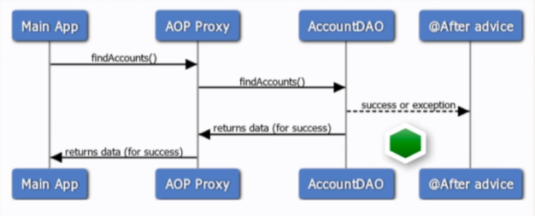This advice runs after the method is completed regardless of outcome/exceptions. This advice will always run as our finally block of try and catch in java.

**@AfterThrowing and @After, which will execute first?**

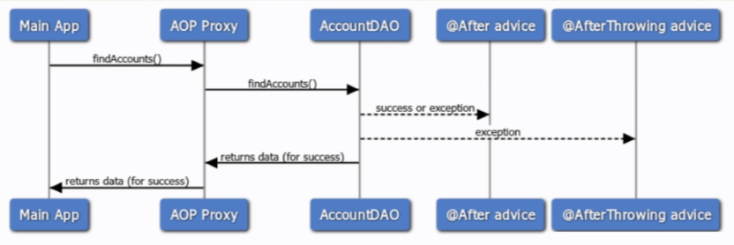@After will execute before @AfterThrowing. It’s just like in try catch where finally will always execute before the exception is being thrown.

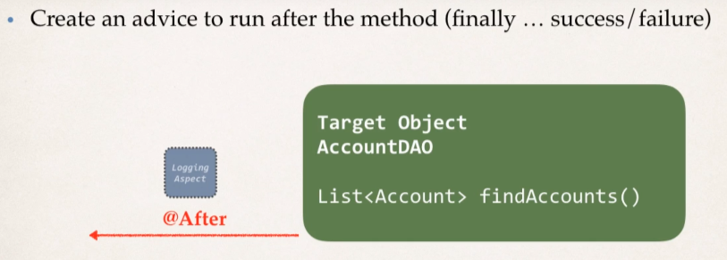**Example:**

**Coding @After Advice**

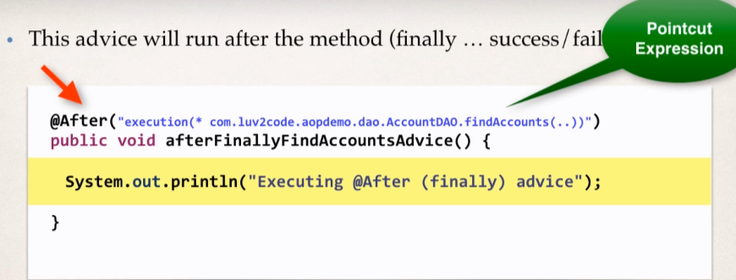

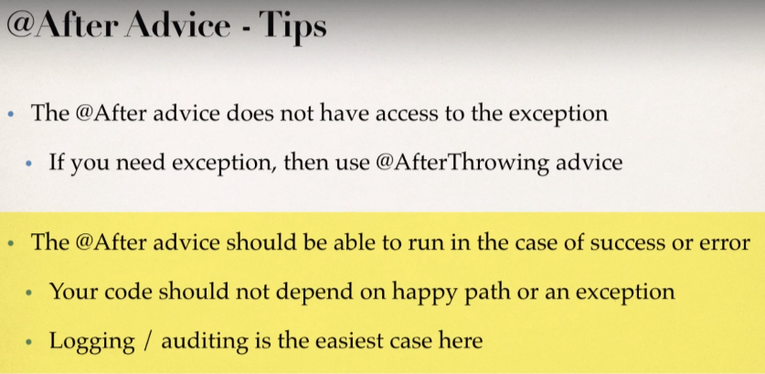

Development Process:

1. Prep work
2. Add @After Advice
3. Test for failure/ exception case
4. Test for success case.

* 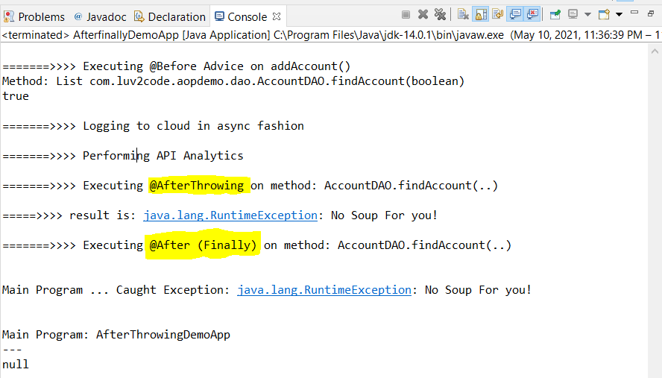In case of failure/exception; **output:**

As we have discussed that @AfterThrowing will execute after @After advice but here it’s happening otherwise.

* 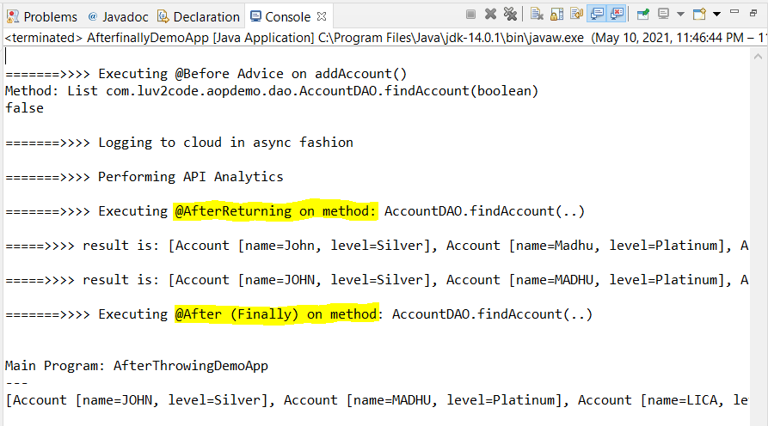In case of success; **output:**

Again, the same thing is happening, So, we have the reason regarding this below:

HEADS UP - @After Advice running after @AfterThrowing advice

You may have noticed that in the latest versions of Spring, the @After Advice is running **AFTER** the @AfterThrowing advice. This output is different than what I showed in the original video.

There were recent changes in the Spring 5.2.7 (released on 9 June 2020).

Starting with Spring 5.2.7:

- if advice methods defined in the same @Aspect class that need to run at the same join point

- the @After advice method is invoked AFTER any @AfterReturning or @AfterThrowing advice methods in the same aspect class

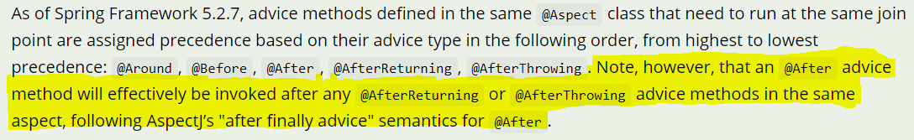So, in our case, the @After and @AfterThrowing are in the same aspect class: MyDemoLoggingAspect.java, hence in latest Spring 5.2.7, the @After will run AFTER the @AfterThrowing.



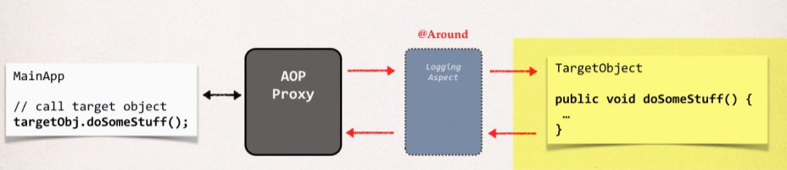**@Around Advice:** [Java Project Link](https://github.com/000GEV744/Spring-Git/tree/main/Spring-demo-aop-zz-around-handle-exception)

This advice will run before and after the method execution.

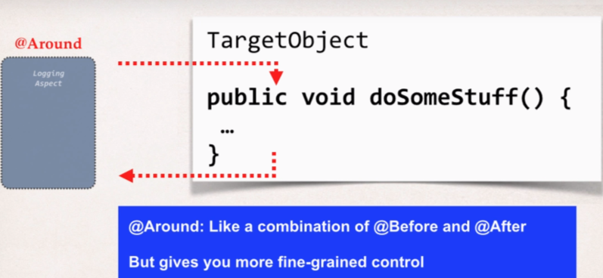**Use Case**:

1. Most common: Logging. Auditing, security
2. Preprocessing and Post Processing data.
3. Instrumentation/profiling code.

i.e., How long does it take for a section of code to run?

4. Manage Exceptions

i.e., Swallow/handle/stop Exception

There may be cases where we don’t want exception to propagated all the way to the main app.

Here for Example, we will revisit our FortuneService that we have discussed initially in the course:

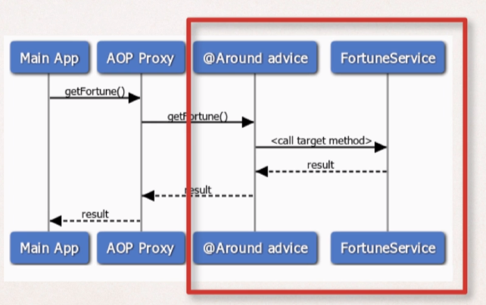**Sequence Diagram:**

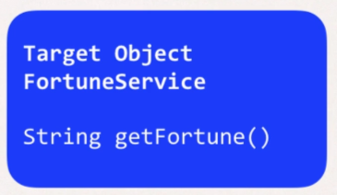

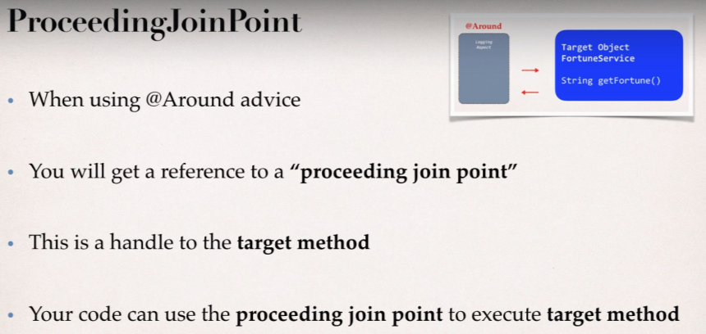

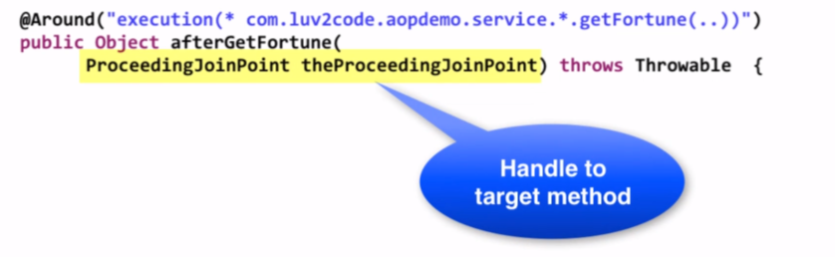When we make use of the @Around Advice, then we get a reference of proceeding JoinPoint.

**Example:**

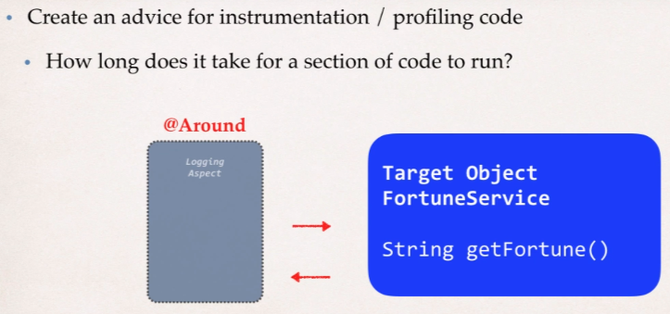 Here, we will check how long does a method take to run.

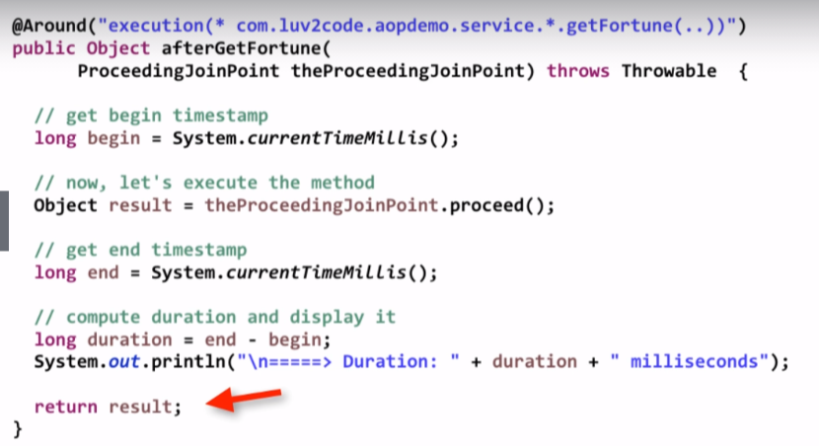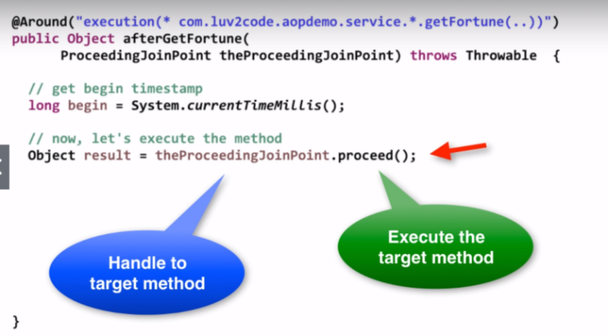**Coding:**

We are getting the duration and printing it onto the console and then finally returning the result to the calling program.

**Development Process:**

1. Prep Work
2. Create TrafficFortuneService

**File:** [TrafficFortuneService.java](https://github.com/000GEV744/Spring-Git/tree/main/Spring-demo-aop-zz-around/src/com/luv2code/aopdemo/service)

**public** **class** TrafficFortuneService {

**public** String getFortune() {

//simulate a delay

**try** {

TimeUnit.***SECONDS***.sleep(5);

} **catch** (InterruptedException e) {

e.printStackTrace();

}

//return a fortune

**return** "Expected Heavy Traffic this morning";

}

}

1. Update main app to call TrafficFortuneService

**File:** [AroundDemoApp.java](https://github.com/000GEV744/Spring-Git/blob/main/Spring-demo-aop-zz-around/src/com/luv2code/aopdemo/AroundDemoApp.java)

//read spring config java class

AnnotationConfigApplicationContext context =

**new** AnnotationConfigApplicationContext(DemoConfig.**class**);

TrafficFortuneService theFortuneService = context.getBean("trafficFortuneService",TrafficFortuneService.**class**);

System.***out***.println("\nMain Program: AroundDemoApp");

System.***out***.println("Calling Fortune");

String data = theFortuneService.getFortune();

System.***out***.println("\nMy Fortune is: "+data);

System.***out***.println("FINISH");

//close the context

context.close();

1. Add @Around Advice.

**File:** [MyDemoLoggingAspect.java](https://github.com/000GEV744/Spring-Git/blob/main/Spring-demo-aop-zz-around/src/com/luv2code/aopdemo/aspect/MyDemoLoggingAspect.java)

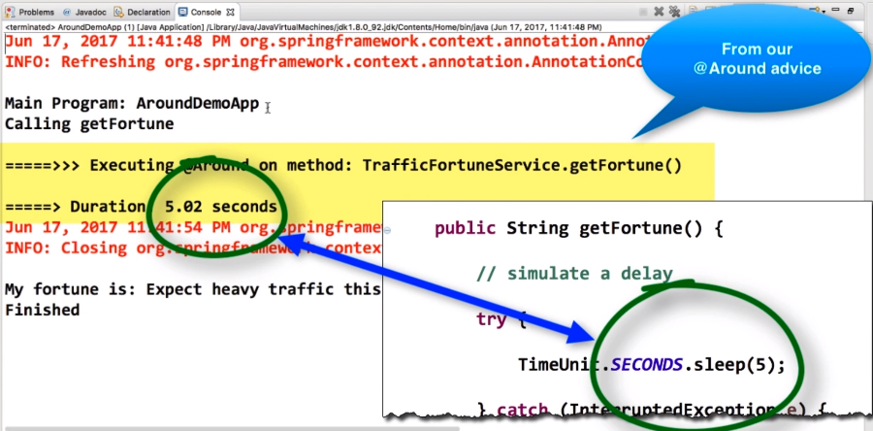**Output:**

As in the above output we can see that our output on the console is being printed out in the end.

**So, we need to resolve this order issue:**

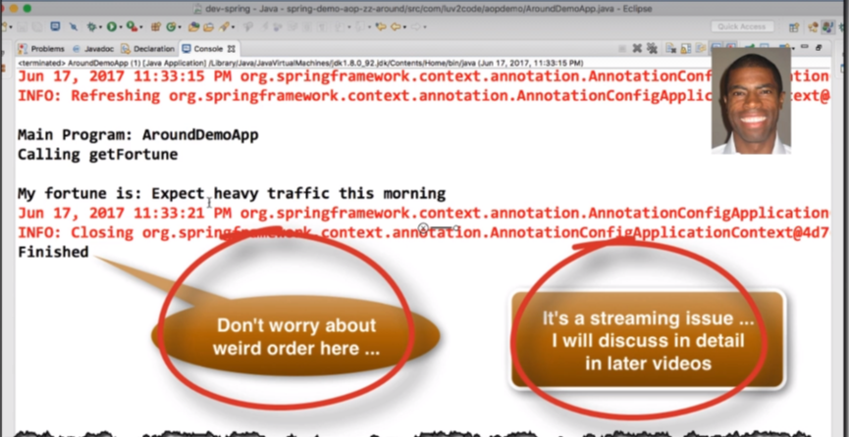Here is the sample:

**Root cause:**

1. Data is printing to two different output streams.
2. Spring is printing to the logger output stream
3. System.out.println is printing to the standard out output stream.

**Solution:**

1. To have everything in order, you should send to same output stream
2. We’ll change our code to use the logger output stream…same as Spring.

**File:** AroundWithLoggerDemoApp.java

**public** **class** AroundWithLoggerDemoApp {

**private** **static** Logger *myLogger* = Logger.*getLogger*(AroundWithLoggerDemoApp.**class**.getName());

**public** **static** **void** main(String[] args) {

...

}

}

And Replace all the System.out.println with myLogger.info.

**File**: MyDemoLoggingAspect.java

Perform the same thing as we did above.

And in the **output** we will get everything in order.

* **@Around Advice – Handle Exception** [Java Project Link](https://github.com/000GEV744/Spring-Git/tree/main/Spring-demo-aop-zz-around-handle-exception)

**ProceedingJoinPoint:**

* For an exception thrown from proceeding Join point

1. You can handle.swallow /stop the exception
2. Or you can simply rethrow the exception

* This gives you fine-grained control over how the target method is called.

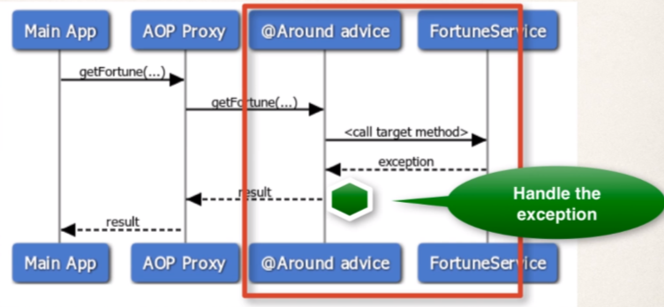**Sequence diagram**

So, when the exception is thrown, we actually handle it at our @Around Advice and in @Around Advice we can log the exception and we will assign a default fortune that we can pass back as a result of the main program, and the main program will never know that the exception is thrown as we have handled it in our @Around Advice.

**Handling Exception**

We will keep theProceedingJoinPoint.proceed() inside the try catch block because if anything goes wrong while calling that method, then we can handle that in the catch block.

1. First, we are logging the exception.
2. Then, we are giving the default fortune to the calling method.
3. 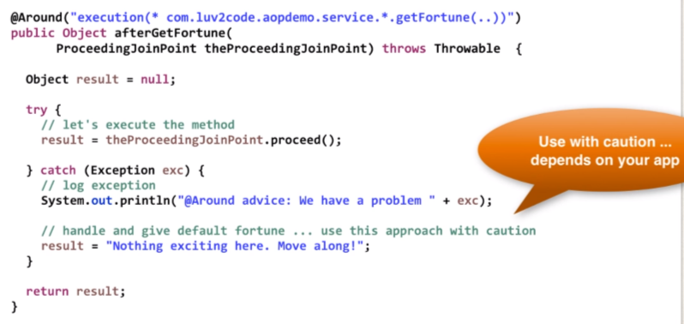At bottom, we are returning the result.

Here, we can rethrow the exception or assign a default value and it really depends upon our application.

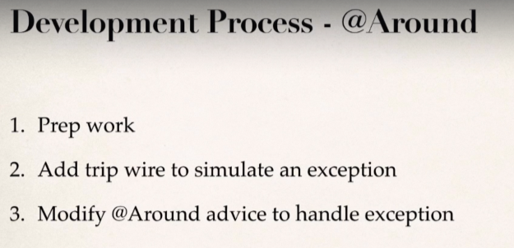

**File:** [AroundHandleExceptionDemoApp.java](https://github.com/000GEV744/Spring-Git/blob/main/Spring-demo-aop-zz-around-handle-exception/src/com/luv2code/aopdemo/AroundHandleExceptionDemoApp.java)

**boolean** tripWire = **true**;

String data = theFortuneService.getFortune(tripWire);

**File:** [TrafficFortuneService.java](https://github.com/000GEV744/Spring-Git/blob/main/Spring-demo-aop-zz-around-handle-exception/src/com/luv2code/aopdemo/service/TrafficFortuneService.java)

**public** String getFortune(**boolean** tripWire) **throws** Exception {

**if**(tripWire) {

**throw** **new** Exception("Major Accident! Highway is closed");

}

**return** getFortune();

}

**File:** [MyDemoLoggingAspect.java](https://github.com/000GEV744/Spring-Git/blob/main/Spring-demo-aop-zz-around-handle-exception/src/com/luv2code/aopdemo/aspect/MyDemoLoggingAspect.java)

@Around("execution(* com.luv2code.aopdemo.service.*.getFortune(..))")

**public** Object aroundGetFortune(

ProceedingJoinPoint theProceedingJoinPoint) **throws** Throwable {

//print out which method we are advising on

String method = theProceedingJoinPoint.getSignature().toShortString();

myLogger.info("\n=======>>>> Executing @Around on method: "+method);

//get begin timestamp

**long** begin = System.*currentTimeMillis*();

//now, let's execute the method

Object result = **null**;

**try**{

result = theProceedingJoinPoint.proceed();

}

**catch** (Exception e) {

//log the exception

myLogger.warning(e.getMessage());

//give user a custom message

result = "Major Accident! but no Worries,"

+ "your orivate AOP Helicopter is on the way!";

}

//get end timestamp

**long** end = System.*currentTimeMillis*();

//compute duration and display it

**long** duration = end-begin;

myLogger.info("\n====>> Duration: "+duration/1000.0+" seconds");

**return** result;

}

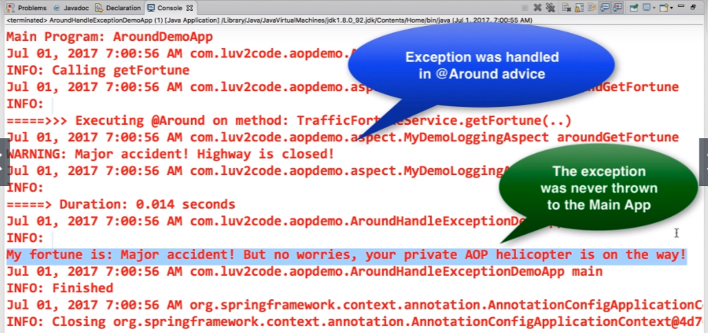**Output:**

* **Rethrow the Exceptions**

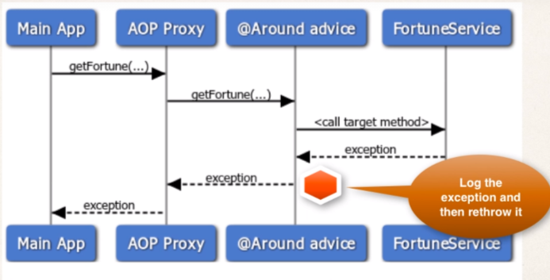**Sequence Diagram**

We need to do some minor changes to our project. Comment our the previously made custom message.

File: MyDemoLoggingAspect.java

//now, let's execute the method

Object result = **null**;

**try**{

result = theProceedingJoinPoint.proceed();

}

**catch** (Exception e) {

//log the exception

myLogger.warning(e.getMessage());

/*//give user a custom message

result = "Major Accident! but no Worries,"

+ "your orivate AOP Helicopter is on the way!";*/

//rethrow Exception

**throw** e;

}

And Call the main() app and will get the exception thrown to the calling method.

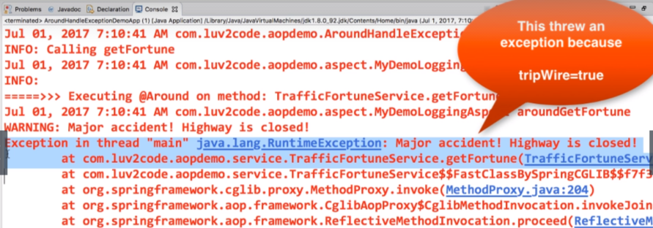**Output:**